**Data Analysis**

**Xiaomi vs Samsung**

Introduction:

I chose Xiaomi and Samsung to understand which company is better or whose product is of better quality. They both trade in the electronics industry and neither of them is particularly far behind the other and to understand who is better, I prepared these questions and plot of comparing shares of both companies.

Questions:

1. Whose shares are more expensive?

2. Which one is more popular?

3. Which one has bigger sales volume?

4. What is average rating for popular Xiaomi and Samsung products?

5. Which one has more increased shares?

6. When was Xiaomi and Samsung’s shares peaks?

7. What is correlation between rating and price of smartphones of both?

8. What is average price of popular Samsung and Xiaomi products?

9. When was a biggest increase for both shares?

10. What is standard deviation, mean, variance, max and min values of shares price of both?

Plot:

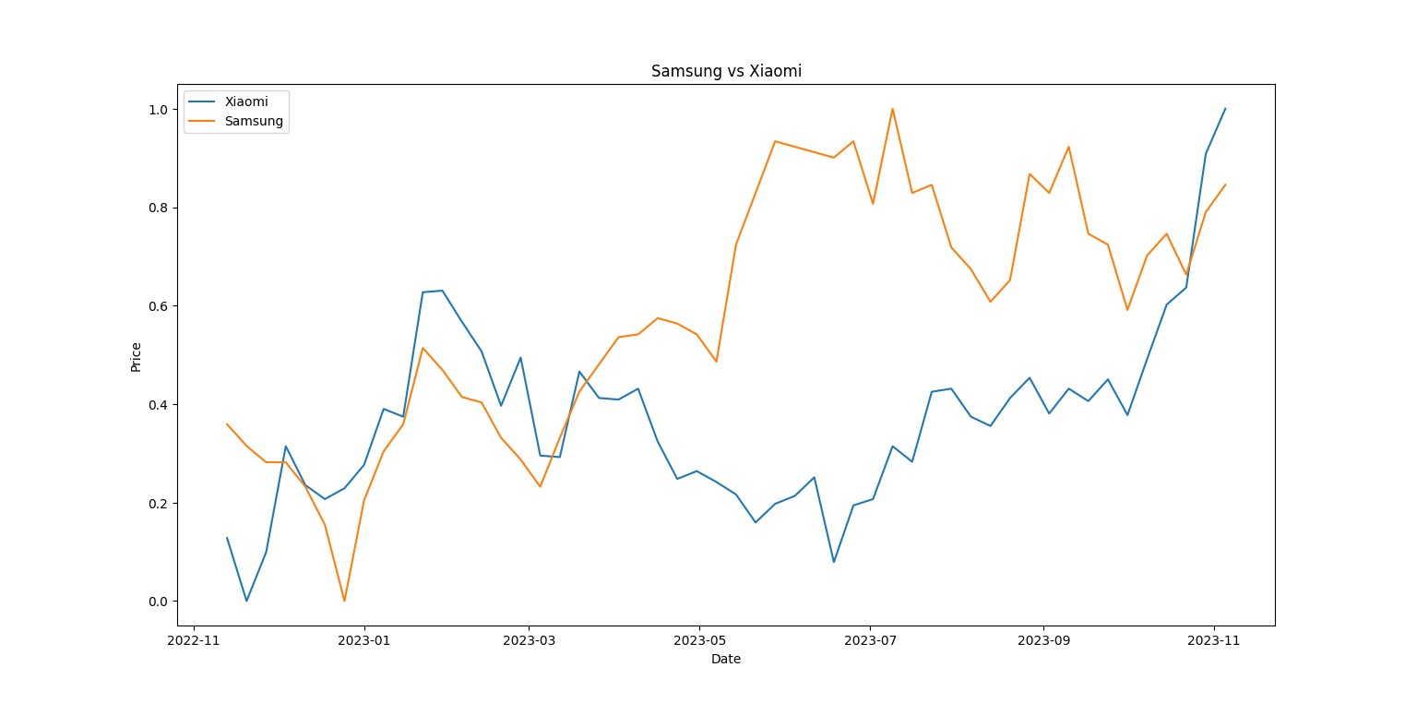

Answers:

I took data from two websites, [www.technodom.kz](http://www.technodom.kz) to compare products, ratings and reviews and [www.investing.com](http://www.investing.com) to compare stocks and sales volume. To answer I used python code with pandas and numpy libraries.

Question1:

I compared data in investing, calculated the average price in USD for each of them and got results. Average price of Samsung’s shares is 49.4 and average price of Xiaomi’s shares is 1.42. Then Samsung’s shares are more expensive than Xiaomi’s.

Question2:

I compared count of feedbacks in technodom. Samsung has 204 feedbacks and Xiaomi has 52 feedbacks. Then we can say customers buy Samsung’s smartphones mare than Xiaomi’s and Samsung is more popular as brand.

Question3:

Based on data in investing Xiaomi has sales volume in billions when Samsung has only millions. Sum of them for Xiaomi is 18.4B and for Samsung is 3.17B. Because of this, Xiaomi’s shares bought and sold by customers more than Samsung’s. It says about potential of Xiaomi.

Question4:

I calculated average rating of Xiaomi in Technodom, it is 4.82, and rating of Samsung is 4.78.

Question5:

I calculated the change of shares, for Samsung it is +14.24%, and for Xiaomi it is +53.6%.

Question6:

For Xiaomi peek of shares was in 5 November in 2023, for Samsung peek of shares was in 9 July in 2023.

Question7:

We can say there is neutral correlation, because for Xiaomi it is already zero and for Samsung it is 0.28.

Question8:

For Samsung average price of top products is 286K and for Xiaomi it is 422K

Question9:

For Samsung biggest increase was in 14 May in 2023 with +6.71% and for Xiaomi it was in 22 December in 2023 with +13.5%.

Question10:

Standard deviation: Samsung 3.36, Xiaomi 0.14. Maximum value: Samsung 55, Xiaomi 1.9. Minimum value: Samsung 41.48, Xiaomi 1.14. Variance: Samsung 11.29, Xiaomi 0.02.

Name: Raiymbek

Surname: Zhanuzak

ID: 220107020